HOUSE RENTAL MANAGEMENT SYSTEM

# PROJECT REPORT

## SUBMITTED IN FULFILLMENT OF THE REQUIREMENT FOR THE AWARD OF DIPLOMA

**IN**

**COMPUTER ENGINEERING**

**SUBMITTED BY**

**Bule Sakshi Sampat (10) : 1901300068**

**Chaube Vrushali Birendra (11) : 1901300069**

**Jadhav Pallavi Rajendra (27) : 1901300085**

**Jagtap Priti Tukaram (28) : 1901300086**

**Kunjir Tejal Ajit (38) : 1901300096**

**GUIDE**

**MR. N.B.Nake**



**DEPARTMENT OF COMPUTER ENGINEERING, GOVERNMENT POLYTECHNIC, AHMEDNAGAR**

**(2021-22)**

**GOVERNMENT POLYTECHNIC, AHMEDNAGAR**



**CERTIFICATE**

**This is to certify that,**

| **Bule Sakshi Sampat** | **(1901300068)** |
| --- | --- |
| **Chube Vrushali Birendra** | **(1901300069)** |
| **Jadhav Pallavi Rajendra** | **(1901300085)** |
| **Jagtap Priti Tukaram** | **(1901300086)** |
| **Kunjir Tejal Ajit** | **(1901300096)** |

of Final Year Computer Engineering (Diploma) students have submitted their project report on

# “House Rental Management System”

during academic session 2021- 2022 as a part of project work described by Government Polytechnic, Ahmednagar for fulfillment for the Diploma in Computer Engineering in the fifth semester.

The project work is the record of student’s own work under my guidance and to my satisfaction.

**Mr. N. B. Nake Mr. S. D. Muley**

**Guide Head**

**Department of Computer Engineering**

**Mr. B. M. Kardile**

**Principal**

**Government Polytechnic, Ahmednagar**

## ACKNOWLEDGEMENT

### I would like to place on record my deep sense of gratitude to Prof. N.B.NAKE , Dept. of Computer engineering for his generous guidance, help and useful suggestions.

I express my sincere gratitude to **Prof. S.D.MULEY , Head of Dept.** of Computer engineering , for his stimulating guidance, continuous encouragement and supervision throughout the course of present work.

I am extremely thankful to **Prof. B. M. Kardile , Principal,** **of Government Polytechnic Ahmednagar** for providing me infrastructural facilities to work in, without which this work would not have been possible.

I am making this project not only for marks but to also increase my knowledge once again thanks to all who helped us.

* Bule Sakshi
* Chaube Vrushali
* Jadhav Pallavi
* Jagtap Priti
* Kunjir Tejal

**ABSTRACT**

The House Rental Management System is Based on the Admins and the Tenants. The Admin is updated on the house details. The Tenant is details about the House space, House rent and the Address Details also. The Rental Management System is best Suitable for admins because time save and the only contact and the eligible person and there is no need to explain the House details on the speak.

The Rental Management System is best website in the city place. The tenant contact and the easily search and the suitable place of Apartment, House and based on the Money, Limit Person is based on the suitable house. The Rental Management System saves the time as well as cost. The Rental Management System is used to easily identify the suitable place.

The Rental Management System is best way to search the house. The client can pay the house rent using internet banking. If the tenant won’t pay the house rent on time then admin can get legal action about it. Hence this system is best applicable for the above reasons making House rental an easy process through an online system.

# Table of Contents

| Chapter No. | Topic Name | Page No. |
| --- | --- | --- |
| 1 | Introduction | 8 |
| 2 | Literature Survey | 9 |
| 3 | Scope of Project | 11 |
| 4 | Proposed Methodology | 12 |
| 5 | Details of Design, Working and Process design | 18 |
| 6 | Results and Applications | 21 |
| 7 | Conclusion and Future Scope | 29 |
| 8 | References and Bibliography | 30 |

**Table of Figures**

| Fig.No | Figure Name | Page No. |
| --- | --- | --- |
| 4.2.1 | Activity Diagram | 13 |
| 4.2.2 | ER Diagram | 14 |
| 4.2.3 | Use Case | 15 |
| 4.2.4.1 | Level 0 DFD | 16 |
| 6.1 | Home Page | 21 |
| 6.2 | Admin Login Page | 21 |
|  | Add/Update House |  |
|  | Manage Tenants |  |
|  | Manage payment |  |
| 6.3 | Tenant Registration Page | 22 |
| 6.4 | Tenant Login Page | 22 |
|  | Book House |  |
| 6.6 | Update Tenant Profile Page | 23 |
| 6.8 | Payment | 24 |
| 7.0 | Contact Page | 25 |
| 7.1 | About Us Page | 26 |

**CHAPTER 1**

**INTRODUCTION**

Talking about the features of the House Rental Management System, the admin can manage the house by entering details such as house number, features, rent, and status. In order to add tenants, the user has to enter the full name, gender, national id, phone number, email, registration date, house, agreement document, status, and exit date. Besides, the admin can add payments too. For payment, the user has to select a tenant, paid amount, balance, date, and comments. Other features include displaying of remaining payments, recent payments, and collected rents.

Design of this project is pretty simple so that the user won’t find any difficulties while working on it. House Rental Management System in PHP helps the user in managing rental records and payments.

House Rental Management System is developed using PHP, CSS, bootstrap, and JavaScript. Talking about the project, it contains an admin side from where admin can manage the house, tenants, payments, and much more.

## Objective of the study

General objective

The main objective of the system is to develop online home rental managementsystem

for wolkite city

Specific objectives

In order to attain the general objective, the following are the list of specificobjectives:

To facilitate home record keeping for who wants home and foradministrative

management system.

prepare an online home rental system for the home finders.

**CHAPTER 2**

**LITERATURE REVIEW**

home is a dwelling-place used as a permanent or semi-permanent residencefor an individual,

family, household or several families in a tribe.You rent aroom in your home that is always available for short-term occupancy by payingcustomers. This room is used solely as a hotel or similar establishment and isnot a dwelling unit.Home is one of the basic needs for human being. From the four need of humanbeing as its need people who have no home may live through paying rent forother people who have more houses. But here what we have to understand isthat the relation between the person who rented house and the renter. Thereare different renters who have different behavior that show differentcharacteristics on rented people. Some renters may have a positive relationshipothers may not. Here those renters who have bad behavior may showunpleasant or bad behavior on rented peoples. But here what we have thoughtis that how those rented people for renter that have bad behavior we livetogether.Renting of home may have advantage as well as disadvantage. Advantages ofrented person from that particular house are renter may work other kind ofwork with the time of constructing that house, he/she may not repair if thathouse deprecates etc. on the other hand the rented may get difficulties or disadvantage from that particular house are payment of period calls may enter disturbance sometimes.

## Problem Identification

Over the years landlords/property managers have had a problem in maintaining and managing their tenants and their own records.

Management has become difficult because of issues that include:

1) Data growth

Data increase day to day. Storing and maintaining all data manually is very difficult

2) Lack of computerized system

Currently most landlords/property managers use the manual system in recording and maintaining their property and tenants data

3) Data security is not assured

In a manual way, data is recorded on books/papers which may easily get damaged leading to loss of data.

## Requirement Specification

Requirement analysis involved defining tenant needs and objectives in the context of planned tenant use, environments and identified system characteristics to determine requirements for system functions.

### User Requirements

It entailed user involvement and statements of facts and assumptions that define the expectations of the system in terms of mission objectives, environment, constraints and measures of effectiveness and suitability. Basically the users:

* + - 1. A system that improves on the efficiency of information storage and retrieval.
      2. A system that is easy to learn and use
      3. A system that is fast in processing transactions
      4. A system that is flexible, safe and convenient

1. **Functional Requirements-**

This is a necessary task, action or activity that was accomplished. The proposed system is able to:

1. Allow administrator to add a houses, tenant and defaulters details
2. Allow the administrator to delete houses, tenants and defaulters details
3. Allow the administrator to search data in the database
4. Allow the administrator to edit data in the database

# Hardware Requirements

* Intel i3 dual core processor with 2.0 Ghz processor speed
* Memory 8GB RAM
* Visual Display Unit 800*600 colours

# Software Requirements

## System Development Software

* + Operating System- windows 10
  + PHP: Version 7.1
  + Xamp Server: Version 7.3.9
  + HTML
  + CSS
  + Cloud Services(Google/Azure)
  + MySql version 8.0

## User Required Software

* + Operating System: Windows 7,8,10
  + Browsers: Google Chrome/Firefox: Version 66 or above

## SCOPE OF THE PROJECT

The scope of House Rental management system is to create an online web interfaces for user to check the availability of the houses in the nearby area. This House Rental management system will be an alternative to traditional of checking the Houses . The House Rental management system will make easy to find the location of Houses, select no. of Houses and other facts by the entered by the tenant. The House Rental management system is best way for a tenant to search the houses which is available in his area. This system will have two major types of users: Tenant and Admin. The Admin will manage all the details and verify the Houses . The scope of this project is to develop a house rental management system that allows the tenants to view no of Houses available near his area and allows the admin to add, update and maintain the tenants record. For students, workers and employees who are away from their home and have a job, college, work in some other city it becomes difficult for them to search the Houses . This website will help such people to find Houses for them. Currently the most property managers manage property and tenant’s details on papers. Once tenants find a vacant houses, they can call through contact us and acquire the house.

**CHAPTER 3**

**METHODOLOGY**

## 1. Problem Statement

* House Rental system has become important factor in modern society hence the need to have a rental house management application. It is difficult to find house for the renter in a specific area. It is also difficult to find the renter on time, for the landlord and property managers. Over the year’s landlord’s/property managers have had a problem in maintaining and managing their tenants and their own records. Management has become difficult because of issues that include:

## Data growth:

Data increase day to day. Storing and maintaining all data manually is very difficult.

## Lack of computerized system:

Currently most landlord’s/property managers use the manual system in recording and maintaining their property and tenant’s data.

## Data security is not assured:

In a manual way, data is recorded on books/papers which may easily get damaged leading to loss of data.

## There is no database to store information:

Potential of data loss or damage is very high because data is stored on tangible files. Lack of these crucial requirements makes management of the tenants and houses very difficult as some tenants may end up not paying rent.

## Architectural Design Specification

**3.2.1 Activity Diagram**

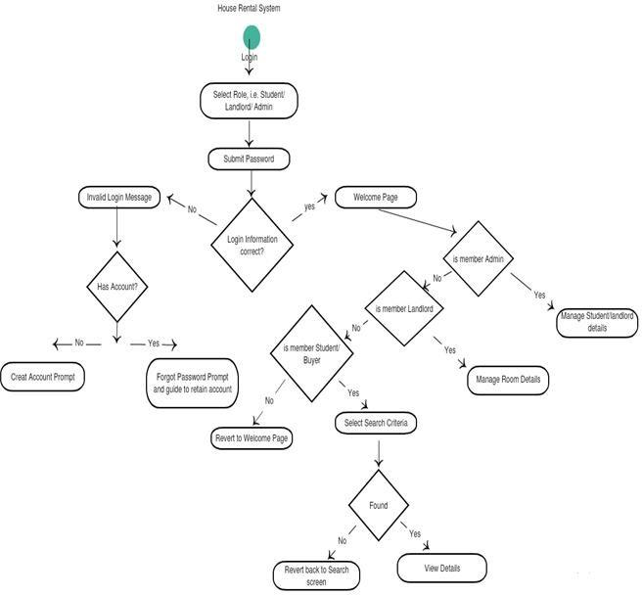

**Fig.3.2.1: Activity Diagram**

## 3.2.2 ER Diagram

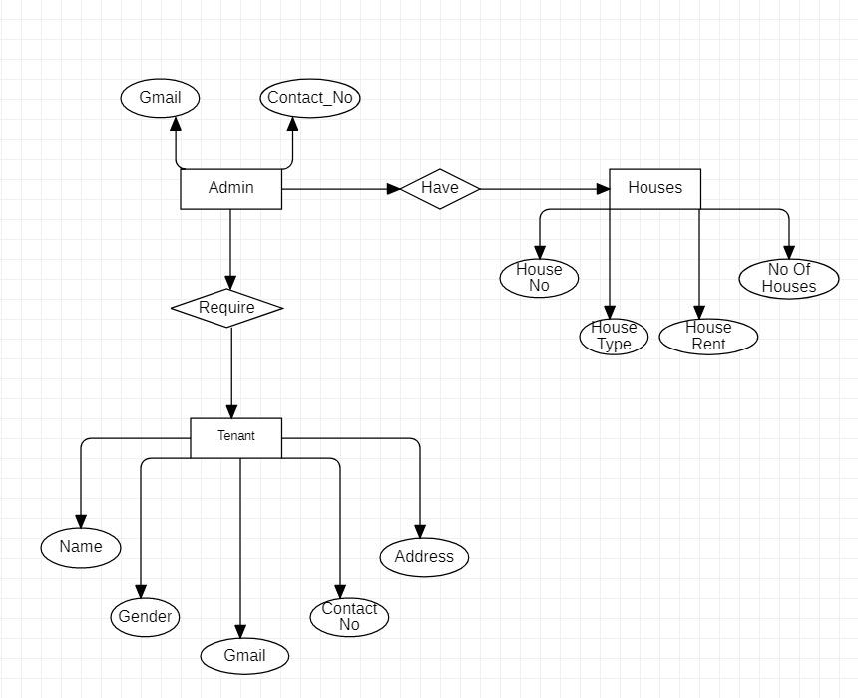

**Fig 3.2.2: ER Diagram**

## 3.2.3 Use Case

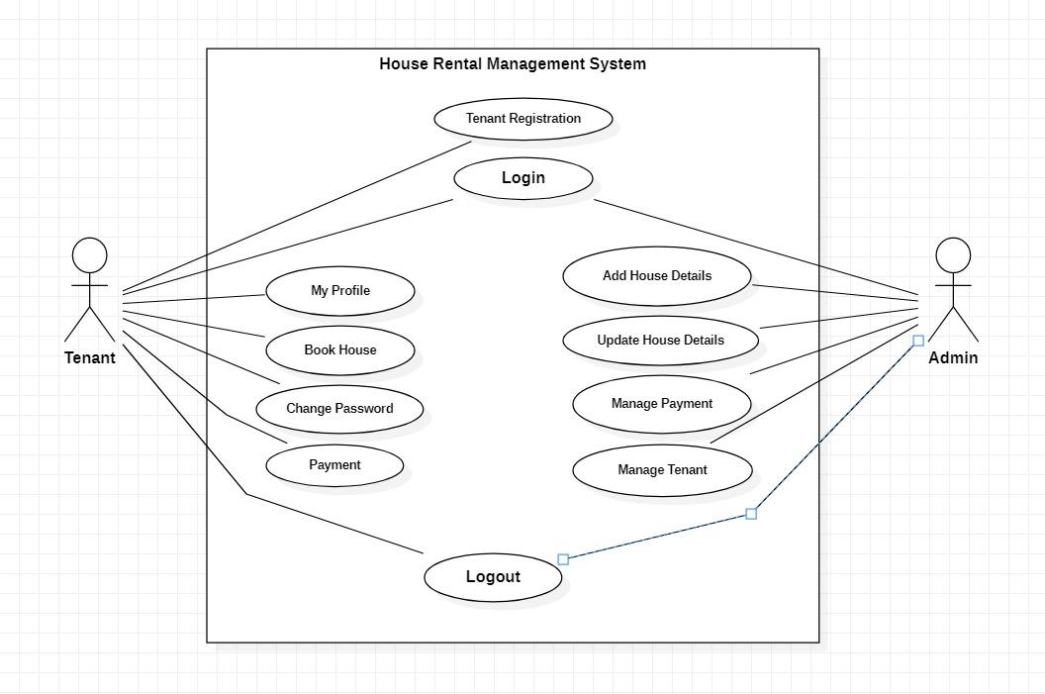

**Fig 3.2.3: Use Case**

## 3.2.4 Data Flow Diagram

* + - 1. **Level 0**

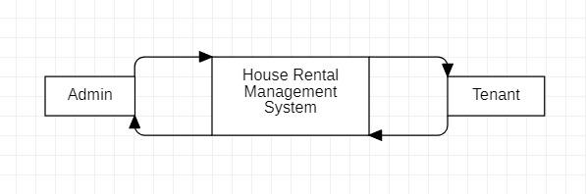

**Fig 3.2.4.1 : Level 0 DFD**

## Level 1

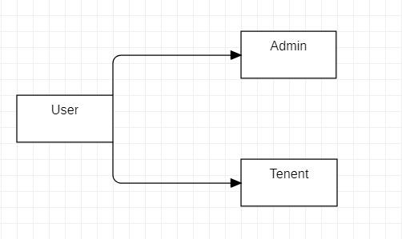

## Level 2

* + - * 1. Tenant

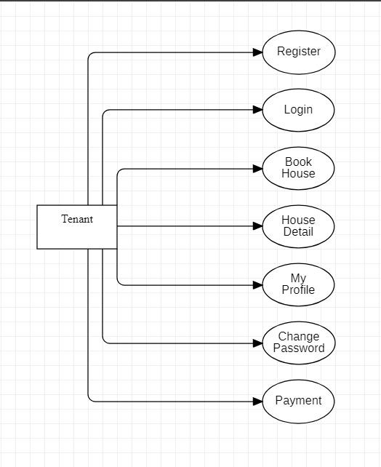

**Fig 3.2.5.1 .A: User**

* + - * 1. Admin

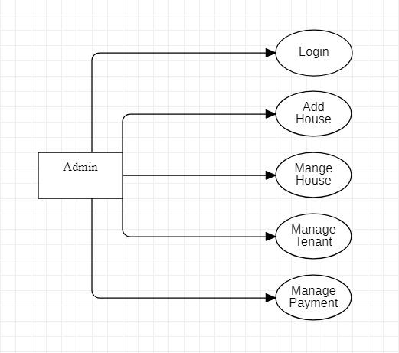

**Fig 4.2.5.1.B: Admin**

## Data Structure

We used MySQL (XAMP server) database for storing the information of user and different auctions. We created 9 tables in the database and performed all operation using these tables.

The structure of tables.

Table 1.0: admin

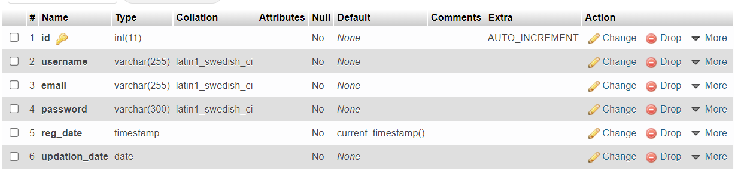

Above Table Stores the information of admin details and type of admin. Here id is primary key.

Table 2.0: adminlog

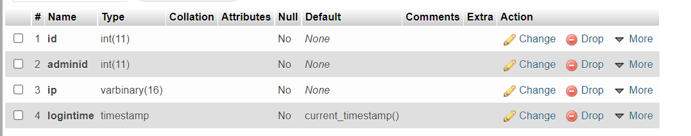

Table 3.0: cources

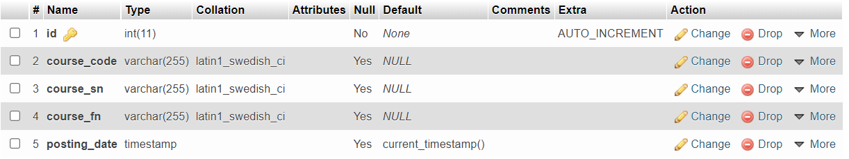

Table 4.0: payment

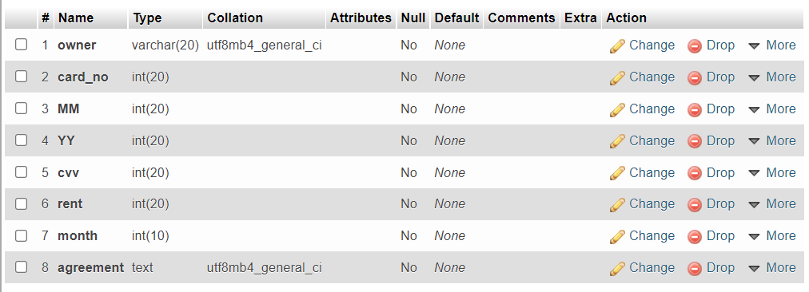

Table 5.0: registration

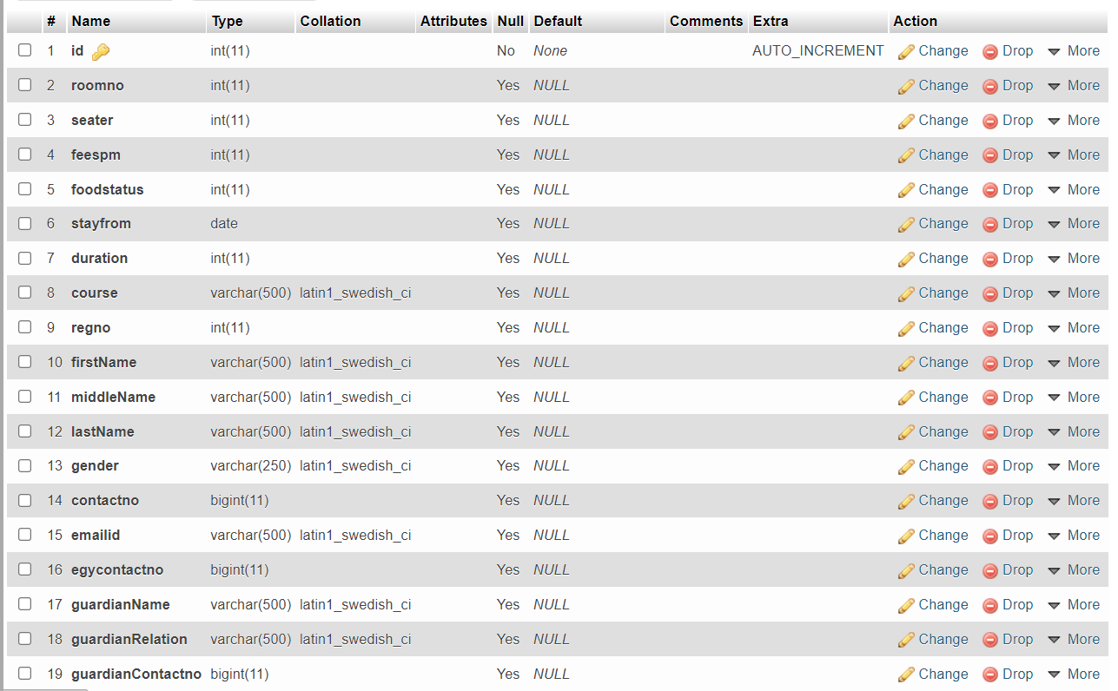

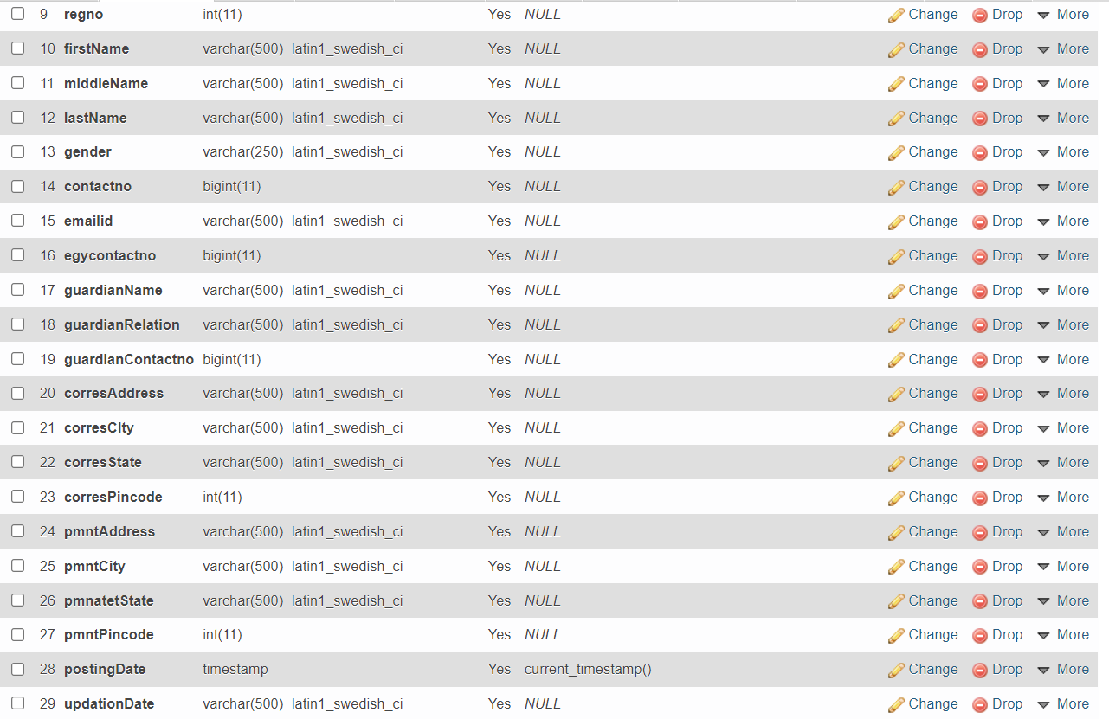

Table 6.0: rooms

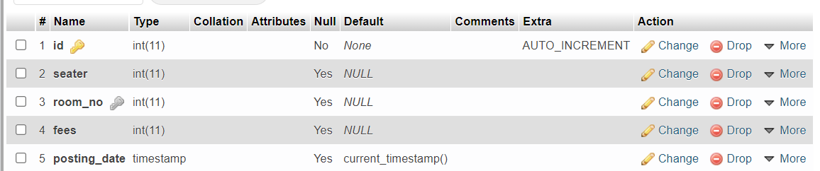

Table7.0:states

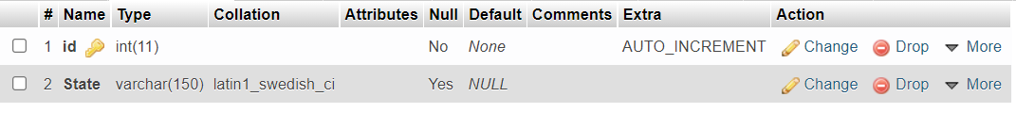

Table 8.0: userlog

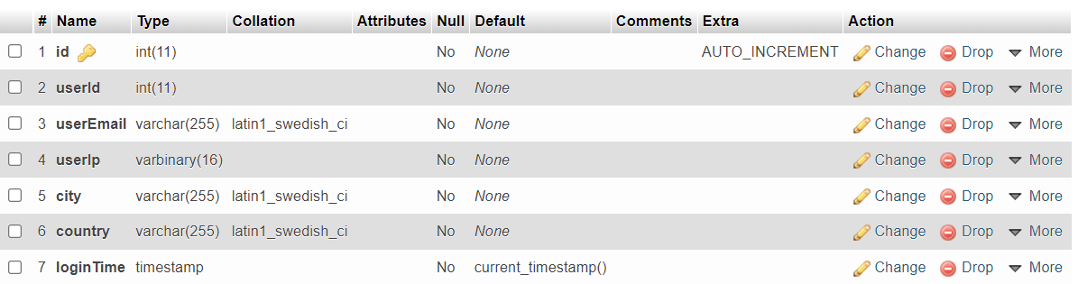

Table 9.0: userregistration

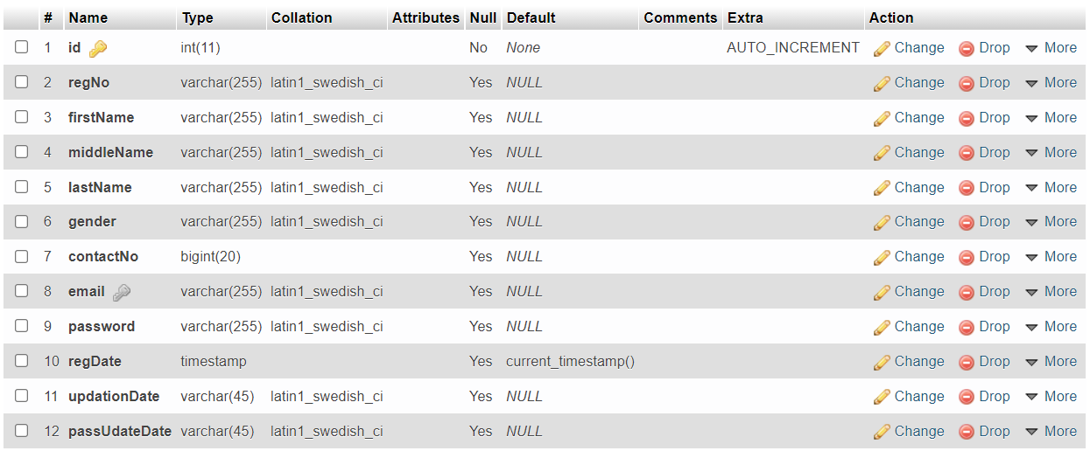

**CHAPTER 4**

**DETAILS OF WORKING**

## Life Cycle Model

## Incremental Model: -

The **incremental model** is a method of software development where the product is designed, implemented and tested incrementally (a little more is added each time) until the product is finished. It involves both development and maintenance. The product is defined as finished when it satisfies all of its requirements. This model combines the elements of the waterfall model with the iterative philosophy of prototyping. The product is decomposed into a number of components, each of which is designed and built separately (termed as builds). Each component is delivered to the client when it is complete. This allows partial utilization of the product and avoids a long development time. It also avoids a large initial capital outlay and subsequent long waiting period. This model of development also helps ease the traumatic effect of introducing a completely new system all at once.

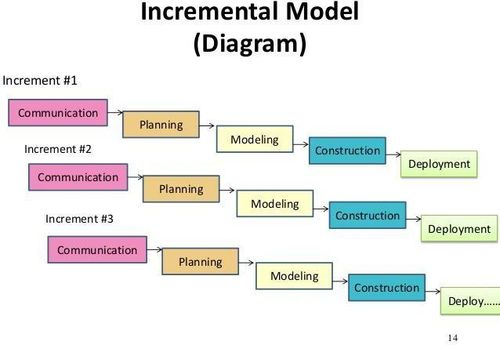

## Team Structure

Teamwork in the workplace is an important factor for project success. Teamwork is important because it creates human synergy. It amplifies the results of each member of your team such that the overall result is greater than the individual contributions made by each member.

Table 6.0: Team Structure

| Member Name | Work |
| --- | --- |
| 1) Bule Sakshi  2) Chaube Vrushali  3) Jadhav Pallavi  4) Jagtap Priti  5) Kunjir Tejal | Main project module designing and coding. (Team Leading) |
| Project Report writing and database designing |
| Project Report writing and Testing |
| Project interface Designing |
|  |

Above table shows the team structure of our team for developing this project. Different types of work have been done by different team member.

## Action Plan

| **Sr.**  **no.** | **Details of Activity** | **Scheduled**  **Date/Duration** | **Name of Responsible**  **Team Members** |
| --- | --- | --- | --- |
| 1. | Designing the code | 19/09/2022 to  05/03/2022 | All team Members |
| 2. | Creation of Database | 05/03/2022 to  12/03/2022 | All team Members |
| 3. | Implementation | 12/03/2022 to  16/04/2022 | All team Members |
| 4. | Testing | 16/04/2022 to  22/04/2022 | All team Members |
| 5. | Project Report Writing | 22/04/2022 to  07/05/2022 | All team Members |
| 6. | Project Report Presentation | 07/05/2022 to  14/05/2022 | All team Members |
| 7. | Project Demo | As Per Instructions | All team Members |
| 8. | Defence | All team Members |

## Development Schedule & Milestone

|  | **Months** | | | | | | | |
| --- | --- | --- | --- | --- | --- | --- | --- | --- |
| **Milestones Achieved** | **Mar 15-**  **Mar 18** | **Mar 26-**  **Mar 29** | **April 5-**  **April 10** | **April 12** | **April 18-**  **April 22** | **May 2-**  **May 8** | **May 13** | **May 18-**  **May 22** |
| **Designing and Coding of GUI(Build 1)** |  |  |  |  |  |  |  |  |
| **Testing and Deployment of Build1** |  | Arrow: Right |  |  |  |  |  |  |
| **Designing and coding of database(Build2)** |  |  |  |  |  |  |  |  |
| **Combining Build1 and Build2** |  |  |  |  |  |  |  |  |
| **Testing and Deployment of (Build+Build2)** |  |  |  |  |  |  |  |  |
| **Designing and Coding of PHP**  **(Build3)** |  |  |  |  |  |  |  |  |
| **Combining Build1,Build2 and Build3** |  |  |  |  |  |  | . |  |
| **Testing and Deployment of (Build+Build2+Build3)** |  |  |  |  |  |  |  |  |

**Programming Languages and Development Tools**

* PHP version 7.1
* Xamp Server version 7.3.9
* Html version 2.0
* Css version CSS 2
* Javascript
* MySql version 8.0
* Cloud Services(Google/Azure) version 80.0.3987.106
* Microsoft Word version 10
* Operating System-Windows 11

## Programming Language and Development Tools

Programming languages are the very important factor for developing any software or website. For developing the website, we require scripting languages. A scripting language is used to write scripts. These contain a series of commands that are interpreted one by one at runtime unlike programming languages that are compiled first before running.

We used following languages for developing the project -

* 1. PHP - PHP is a server side scripting language. that is used to develop Static websites or Dynamic websites or Web applications. PHP stands for Hypertext Pre- processor, that earlier stood for Personal Home Pages. We used PHP for connecting to MySQL database and performing database operation
  2. JavaScript - JavaScript is a very powerful client-side scripting language. JavaScript is used mainly for enhancing the interaction of a user with the webpage. In other words, you can make your webpage more lively and interactive, with the help of JavaScript. JavaScript is also being used widely in game development

and [Mobile](https://www.guru99.com/mobile-testing.html) application development.

* 1. Bootstrap - Bootstrap is a [free and open source](https://whatis.techtarget.com/definition/Free-and-open-source-software-FOSS-or-free-libre-open-source-software-FLOSS) [front end](https://whatis.techtarget.com/definition/front-end) development framework for the creation of websites and [web apps](https://searchsoftwarequality.techtarget.com/definition/Web-application-Web-app). The Bootstrap framework is built on [HTML,](https://www.theserverside.com/definition/HTML-Hypertext-Markup-Language) [CSS,](https://www.theserverside.com/definition/cascading-style-sheet-CSS) and JavaScript ([JS](https://www.theserverside.com/definition/JavaScript)) to facilitate the development of [responsive,](https://whatis.techtarget.com/definition/responsive-design) [mobile-first](https://searchmobilecomputing.techtarget.com/definition/mobile-first) sites and apps.

Development Tools-

We require some software and hardware for developing the project. Coding and Designing of the software is done on these development tools. We used following Development tools for developing the project-

| **Sr**  **No** | **Development Tool** | **Specification** |
| --- | --- | --- |
| 1 | Computer System | Processor Intel Core I3, RAM 8 GB,  1TB.HDD |
| 2 | Operating System | Windows 10 |
| 3 | Microsoft word | Microsoft Office 2016 |
| 4 | Xampp Server ( MySQL database) | version 1.0.0.0 |
| 5. | Notepad++ | version 7.8.3 |

**CHAPTER 5**

**RESULTS AND APPLICATION**

1. **Results**

**Home Page**

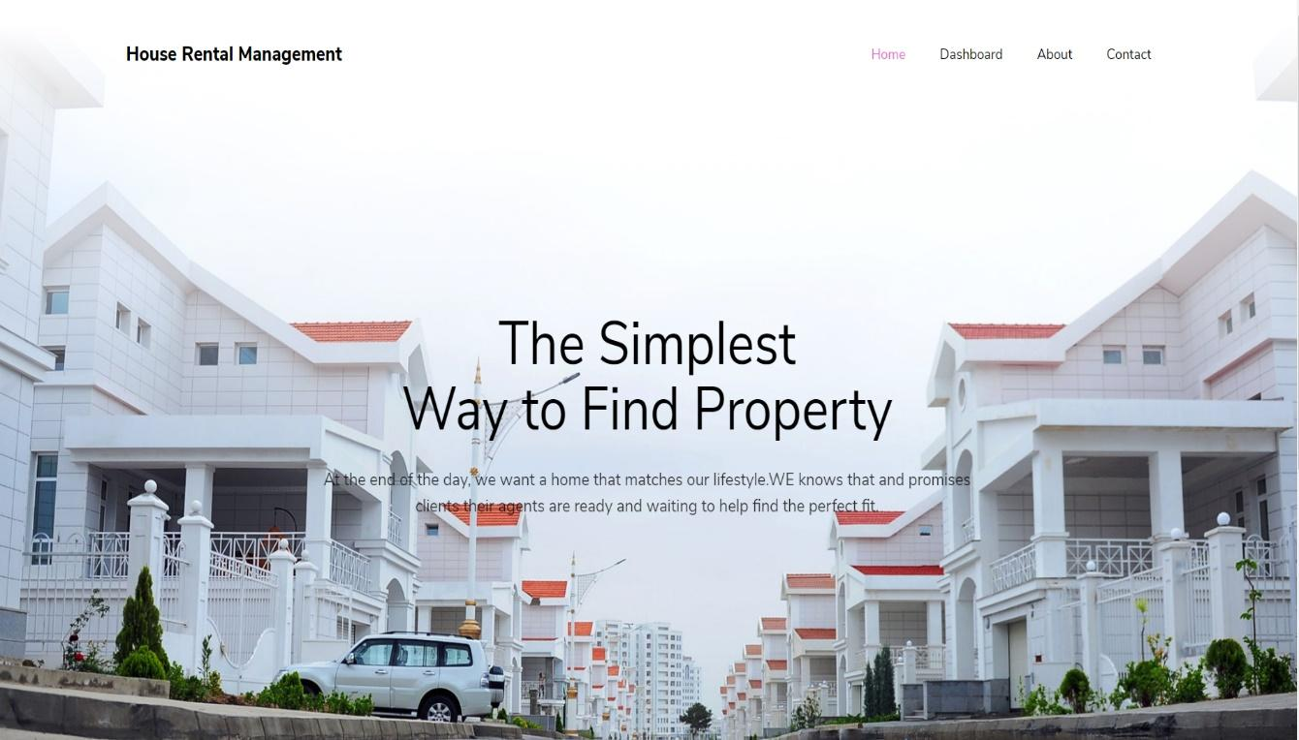

## Admin Login

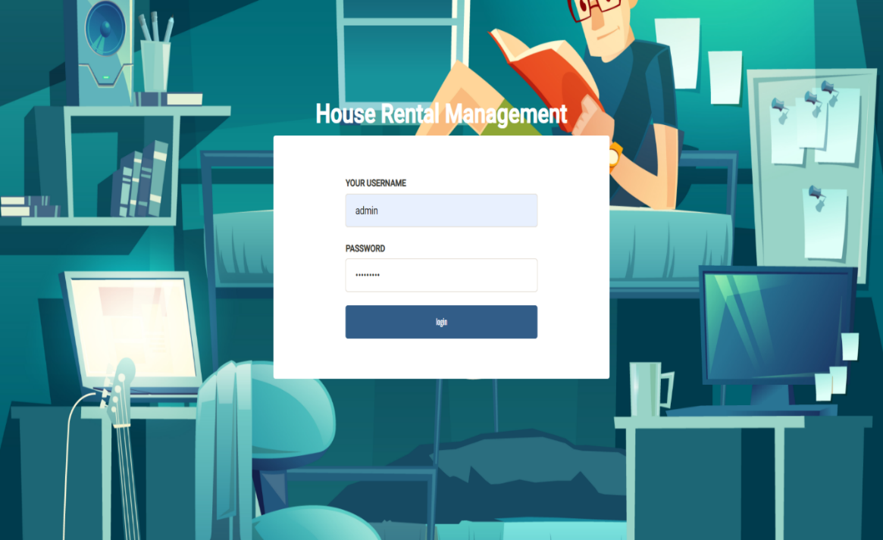

**Add House**

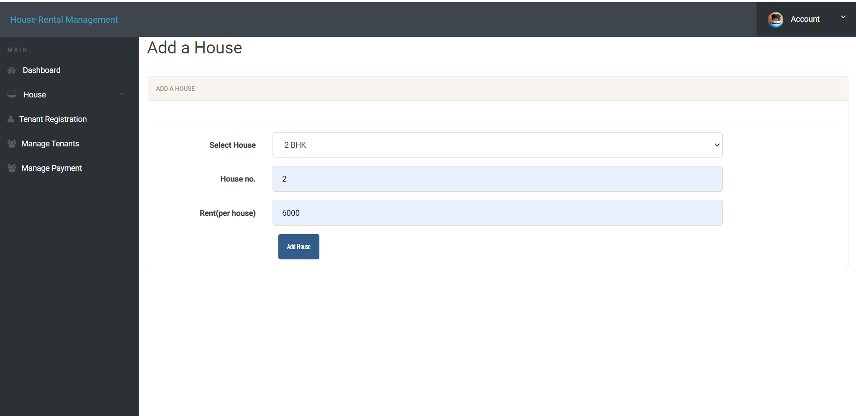

## Manage Tenants

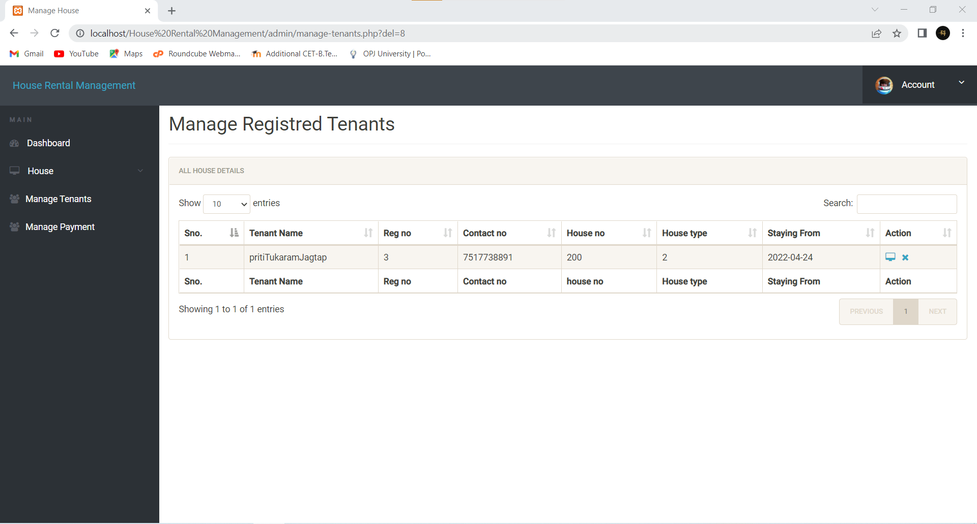

**Manage Payment**

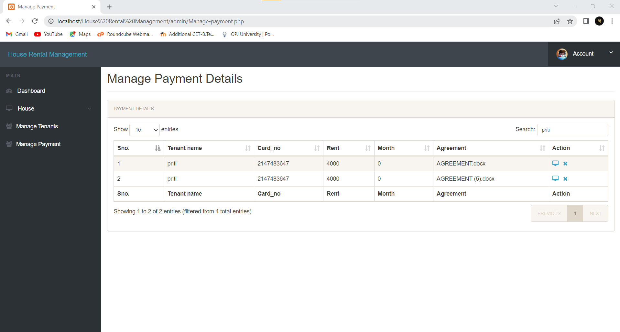

## Tenant Registration

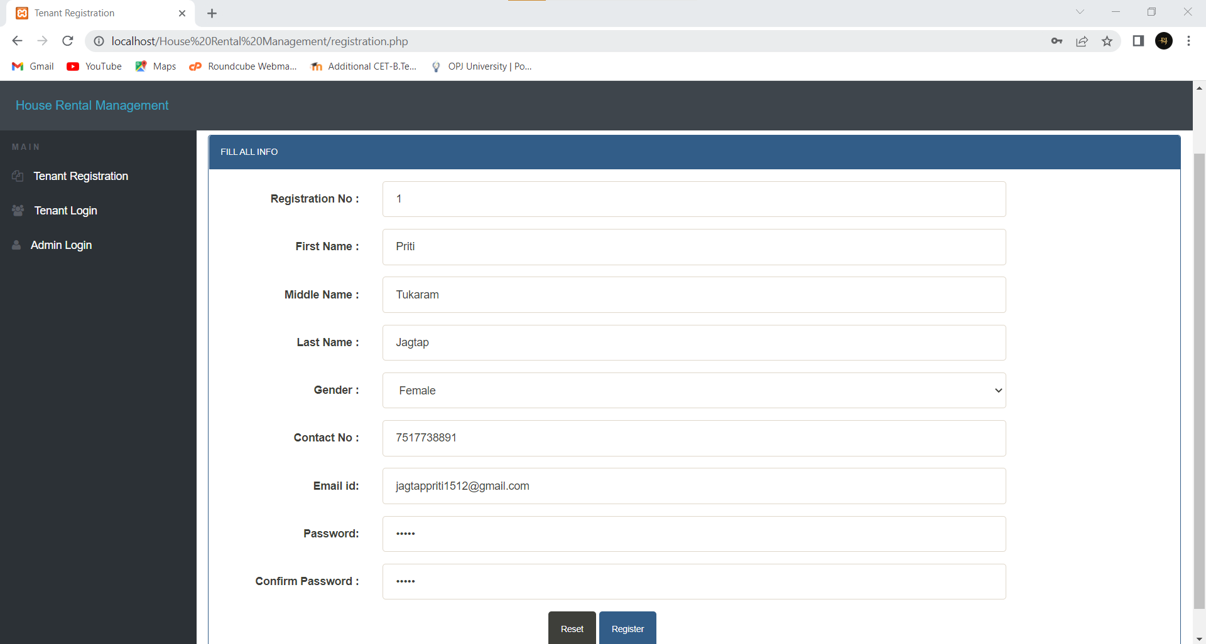

**Tenant login**

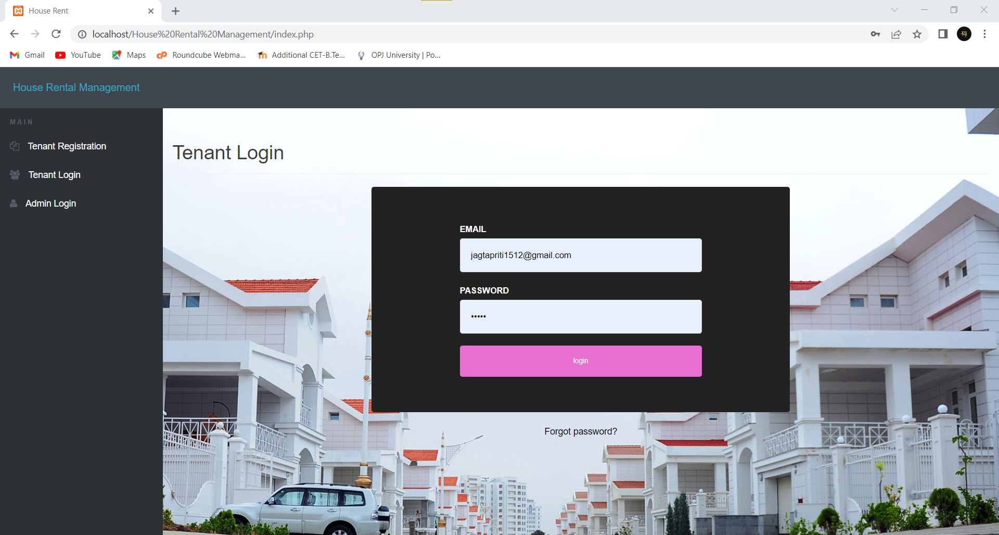

## Book House

## 

## Update Tenant Profile

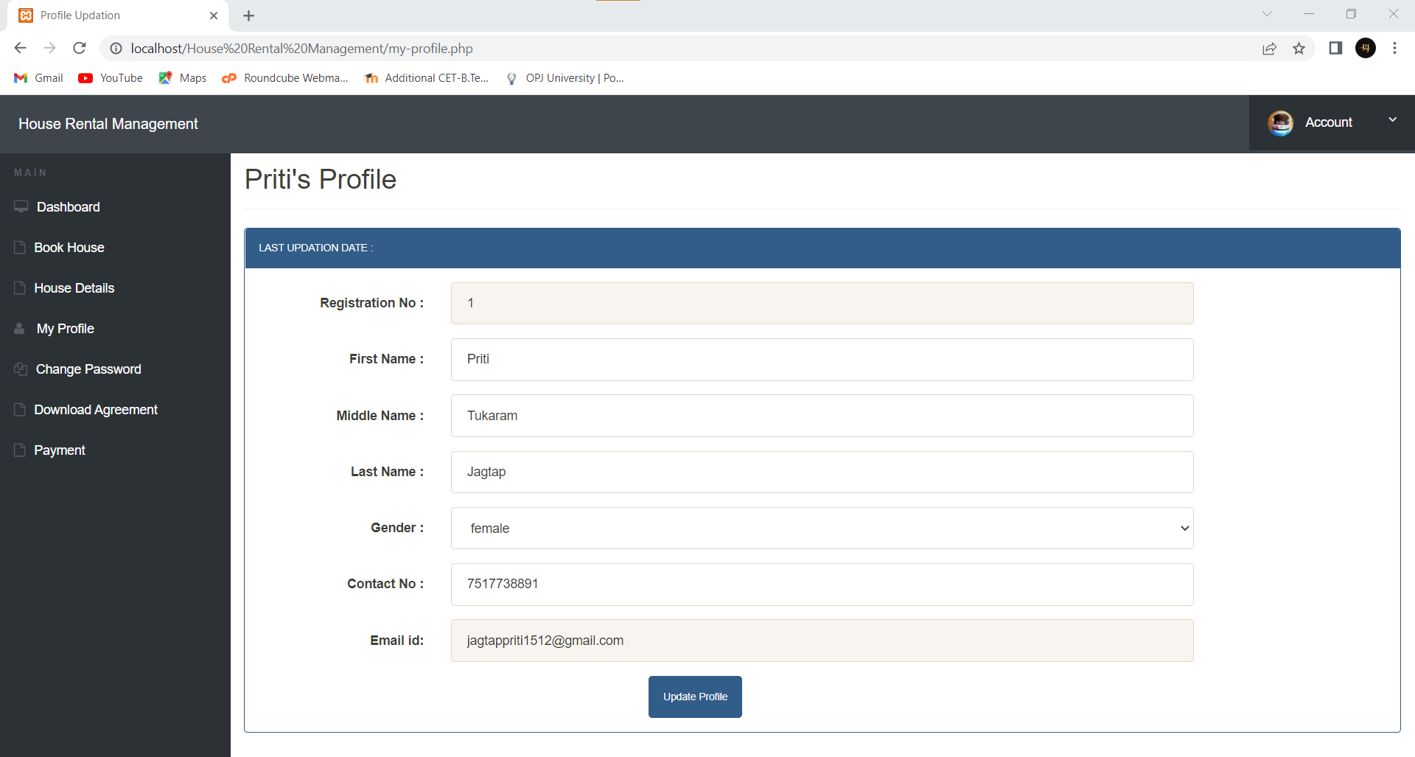

**Payment**

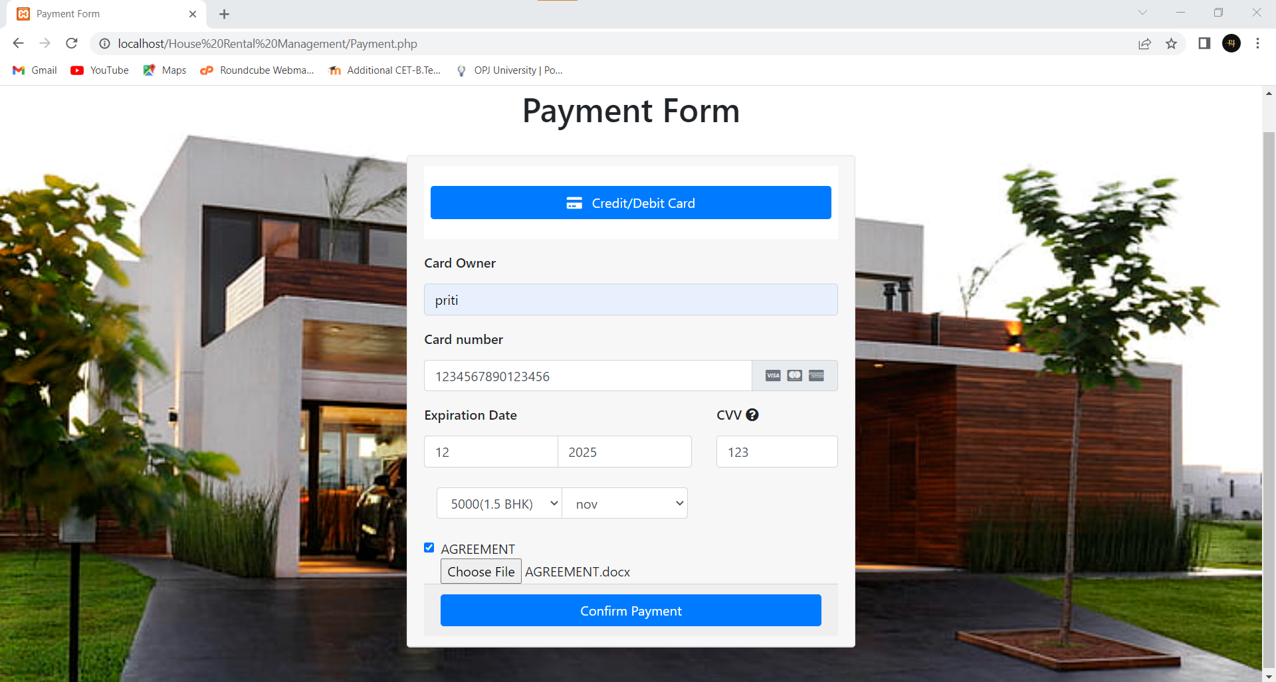

**About Us**

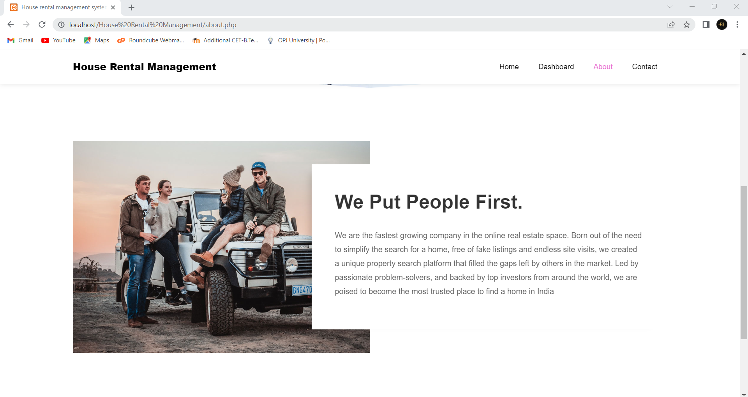

**Contact**

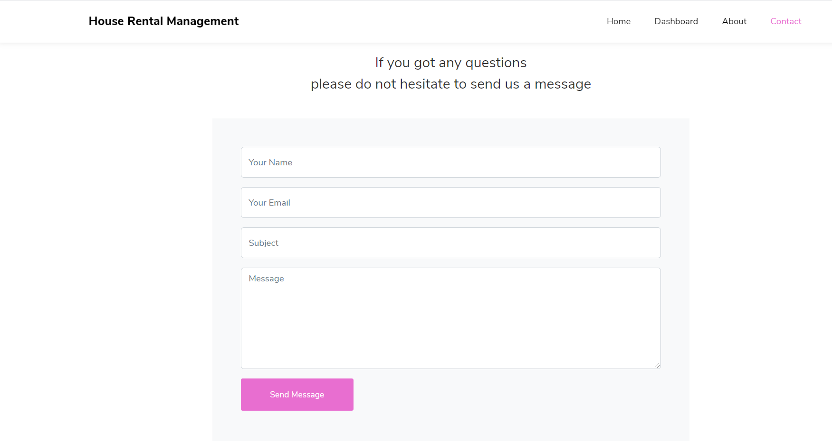

# Applications -

1. This Application will save both time and resources.
2. This will increase the efficiency of current House Rental management system.
3. It will provide all nearby locations to the tenant.
4. Direct communication will be established between tenant and admin.

**CHAPTER 6**

**CONCLUSION AND FUTURE SCOPE**

## 1.0 Conclusion

In last we can conclude that, we have created a user friendly website by using HTML, PHP and CSS. This House Rental management system’s website is going to be very useful for students as well as people who doesn’t know about Houses which are available on rent.

By using this website, they can easily find Houses address as well as House admin’s contact Details. The House Rental management system helps the tenant to easily search the suitable House which is available in his area. Also this website will be very useful and efficient for the House admin’s as they don’t have to maintain any paper work and registers to store the information of the Houses and their tenants. All their information will get stored in database and they can retrieve the data anytime, anywhere without any delay. The website House Rental management system has offered an advantage to both Admins as well as tenants to efficiently and effectively manage the business and satisfies tenants need at the click of a button.

## Future Scope

* Add all type of online Payment System for House booking. It will be very useful if there is online UPI Payment System for House booking. If Tenant wants a House he can directly book the House by UPI Payment system and his House will get booked.
* Adding a Module for listing the number of Houses occupied by Tenant.This Module will be very useful for tenant as he can see which House is occupied and which is not. And tenant will contact only to the House admin whose House is not occupied. This will save the time of tenant.
* Add an SSL Security System.It will be very helpful for the admin. When he will register himself, add House details, update House details, there is a possibility that his data will get tampered. So an SSL Security System is necessary to protect the House admin’s data.

# REFERENCES AND BIBILOGRAPHY

During the development of the project we have used many resources and we have referred various books which are useful for our project.

## Books: -

* Learning PHP, Robert Nixon, 4th Edition
* MySql CookBook, Paul DeBois,3rd Edition
* Software Engineering-A Practitioners Approach, Roger Pressman,4th Edition

## Websites-

1. htt[ps://www.ge](http://www.geeksforgeeks.com/)e[ksforgeeks.com](http://www.geeksforgeeks.com/)
2. htt[ps://www.sit](http://www.sitepoint.com/)e[point.com](http://www.sitepoint.com/)
3. htt[ps://www.tutorialspoint.com](http://www.tutorialspoint.com/)
4. htt[ps://www.w3school.com](http://www.tutorialspoint.com/)